


SAVEETHA SCHOOL OF ENGINEERING

SAVEETHA INSTITUTE OF MEDICAL AND TECHNICAL SCIENCES

COMPUTER SCIENCE AND ENGINEERING PROGRAMME

LAB MANUAL CSA1305

THEORY OF COMPUTATION

COMPUTER SCIENCE AND ENGINEERING PROGRAMME

LIST OF EXPERIMENTS

- Write a C program to simulate a Deterministic Finite Automata (DFA) for the given language representing strings that start with a and end with a

AIM:
To write a C program to simulate a Deterministic Finite Automata (DFA) that accepts strings over the alphabet {a, b} which start with a and end with a.

Apparatus Required
- Computer/Laptop
- GCC Compiler (Turbo C/GCC/CodeBlocks/VS Code)
- C Programming Language

Algorithm
- Start the program.
- Read the input string.
- Find the length of the string.
- Check whether the first character is a.
- Check whether the last character is a.
- Verify that all characters are either a or b.
- If all conditions are satisfied, display "String Accepted by DFA".
- Otherwise, display "String Rejected by DFA".
- Stop the program.

Program Code
#include <stdio.h>#include <string.h>
int main()
{
char str[100];
int i, len;

printf("Enter the string: ");
scanf("%s", str);

len = strlen(str);

if (len > 0 && str[0] == 'a' && str[len - 1] == 'a')
{
for (i = 0; i < len; i++)
{
if (str[i] != 'a' && str[i] != 'b')
{
printf("Invalid input! Only 'a' and 'b' are allowed.\n");
return 0;
}
}
printf("String Accepted by the DFA.\n");
}
else
{
printf("String Rejected by the DFA.\n");
}

return 0;
}

Sample Input 1
Enter the string: aba

Sample Output 1
String Accepted by the DFA.

OUTPUT: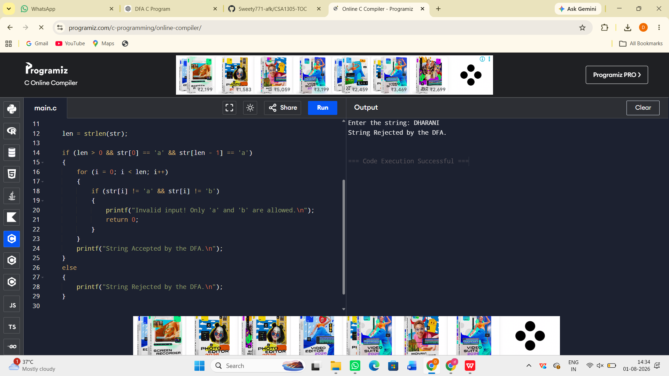

Result:
Thus, the C program to simulate a Deterministic Finite Automata (DFA) for strings that start with a and end with a was successfully implemented and executed. The program correctly accepts valid strings and rejects invalid strings.

